MG US Operations – MCC Corp Agency Business

Business

MCC Corp is the exclusive agent for MCC in North America. MCC Corp negotiates on behalf of MCC (who are the principal) for sales and purchases in the Merchanting i.e. physical, business. MCC Corp charges London a commission for each trade arranged. The underlying business generates profits from taking positions on spreads and also outright exposures. For the US market, trading is almost exclusively basis off COMEX.

Main markets in descending order of size are:

- Copper
- Aluminium (see later notes on Chicago & Montreal offices)
- Zinc

The Copper business expects sales to exceed 500k Short Tons for FY 2000 (typically Copper Cathodes). This equates to:
- turnover in excess of 1m tonnes.
- commission charge to MCC of approximately $7m.
- 35% of MCC’s sales volume.
- 5-10% of the turnover being exchange based.

The business maintains ongoing relationships with producers & consumers, this being a requirement of the long-term nature of the market. These include refineries, Brass mills Smelters, Rod Mills, Die Casters, Tube Mills, the Alloy Industry and Steel Mills. A full list for Copper & Zinc can be found at Appendices 1&2.

The traders in the US provide daily market feedback to the London business and as part of the trading function carry out hedging activities relating to the physical trading. Aluminium is hedged out on the LME and Copper on the COMEX.

A specific subsection of the business is supply of Copper & Zinc to the US mint. For these sales MCC Corp is the principal, the mint preferring to deal with a US company, but then backs them out to MCC in London.

In addition to carrying out the trading activities a large element of the support function is carried out in new York including:

- Contract admin
- Logistics
- Co-ordination of imports & exports

This ties into the market custom in the US. Whereas in most markets metals are CIF or In-warehouse, the US typically trades on Delivery-your-Plant. As a result of this, to compete in the market MG must be able to provide similar levels of support in terms of logistics as found elsewhere.

MCC Corp is able to offer a competitive advantage in the market as they:

- Have access to a wide source of supply, reducing the risk of non-delivery to a consumer.
- Provide full logistics support.
- Can trade large spot quantities – producers typically prefer to sell the production ahead and hence don’t have spare capacity.
- Provide flexibility to producers in terms of ability to take supply.

The overall approach is to take on the admin from both sides of the material flow with the enhanced logistics ability offered in house. Senior management sees logistic becoming a key business tool.

The capital-intensive nature of the business lends itself to development with the use of structured finance and prepayments deals.

Control

Deal Entry

Tickets are raised by traders in 3 locations. These deals must be agreed with London. Merchanting is an extended activity with a small number of trades each day and hence time pressure is not severe. Traders are located in:

- New York
- Montreal
- Chicago

The trade tickets are used by Admin to produce Contract Notes. These are faxed to London and also used in New York to enter all of the North America trades into the AS400 (Alison Smith). This entry into the AS400 will be carried out in the two remote offices when the AS400 rollout is complete. Target date for this is the start of the next financial year (1st October 2000).

Traffic

Inventory is typically stored at coastal LME warehouses although, if available, storage may be at the producer’s or consumer’s site. The bulk of the inventory however is in transit. A rough measure is that for every tonne of sales you need 1 – 1.5 tonnes in transit. This is reflected in the large Copper inventory for the MCC business as a whole. The AS400 system is not very good at dealing with inventory in transit so spreadsheets are used extensively in the logistics area. Development is ongoing to provide sufficient functionality within the AS400 however (Max Chakrabati from the London office specified the requirements).

The traffic function, incorporating logistics, is involved with a large proportion of the deal flow. This starts with the deal entry described above. Traffic receives instructions from the traders providing details of required movements. The traders will have already negotiated rates with the shipping agents – the trader will check with traffic prior to completing a deal what shipping arrangements are in place.

Traffic then take on the responsibility of sending out shipping orders and raising provisional invoices using the AS400. Approximately 10% of invoices are raised manually as the AS400 does not have the appropriate functionality. Copies of these invoices are faxed to London. Once finalisation has taken place on a deal, New York traffic updates the information in the AS400.

Bills of Lading are always required. In the majority of cases these Bills Of Lading are passed onto the end customer who notify traffic of any issues on arrival of the goods. A monthly report is run to show discrepancies and allow true up of the entries in the AS400 as differences between original specific amount and the Bill of Lading will result in small residual amounts residing in the AS400.

Location sheets are used where materials are consignment stock. These are maintained on spreadsheets and reviewed by New York and London traffic at month end to check product that has not been invoiced.

Switch/Exchanges

When purchasing stocks in the continental United States a Switch or Exchange is often adopted. These are paper transactions where both sides of the deal wish to trade at a certain location where product is present. Product is bought and sold without any physical movement.

Traffic maintains contract files for all deals that will contain all Bills of Lading (or advice notes) along with shipping orders and correspondence.

LME Warrants

Material held at LME warehouses is warranted. When trading want to cancel a warrant i.e. take delivery of the material, London traffic provide details to New York traffic. These are used to update the tracking spreadsheet (which is also updated by traffic for any movements arranged by them). The warehouse spreadsheets are reconciled to warehouse inventory lists whenever they are received.

Any transactions with HBI are at a full arms length basis.

Settlements

Invoices are sent out from New York for most of the agency business (see comment below re Chicago & Montreal). Accounts payable are approved in New York by the Traffic department and supplied to London on the cash flow sheet. London traffic enters these into the AS400 and notifies treasury in London. Logistics will then chase this cash and monitor applications by London. The intended restructuring will take all AP/AR work from New York & Chicago and make Montreal responsible for all Aluminium agency settlements.

The Aluminium business changed from being principal to agency recently, as a result there are still invoices being generated in Chicago by the support team there with local support chasing overdue cash amounts. It is likely that the Montreal office is also currently involved in sending invoices out although this has not been verified.

This may extend to some minor Zinc and Aluminium trading primary payments.

Accounting

Full accounting & risk management for the underlying business is carried out in London. On a monthly basis commissions are entered into SAP and London invoiced.

Local accounting for the agency business is maintained in SAP with the business split into Copper (400) and Aluminium/Zinc (470).

Cash Management

Cash payments for primary product are in London. There are however payments made out of New York for accounts payable on freight and the business with the US Mint (where MCC Corp is the principal). These are trued up daily with London who use a printout of the cash flows maintained in the US system.

This process is managed by Harry Zlotnick in conjunction with London treasury – London enters the cash flows into the AS400 on a summary basis to allow split by type.

Organisation

Ultimate reporting for the agency business is into San Hainsworth in London. Local structures are as follows. Chicago and Montreal report into New York for administrative purposes.

MCC Corp Agency Business - New York Business Team

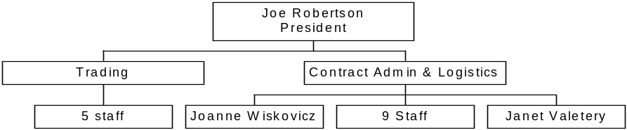

MCC Corp Agency Business - Chicago Business Team

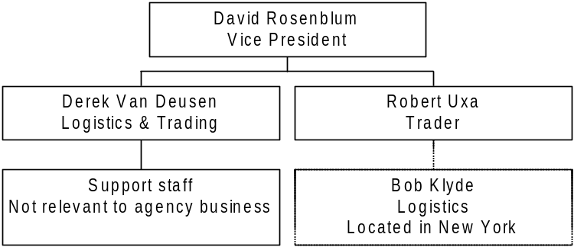

MCC Corp Agency Business - Montreal Business Team

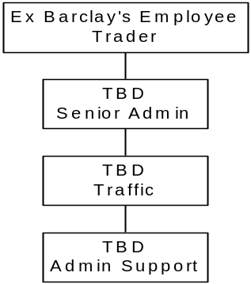

The Montreal team was recently hired from Barclays Metals. They are currently still located in the Barclays’ building and will be moving out by the 1 August 2000. We have not visited this office so have not been able to identify in detail the activities.

The intention within the business is for Montreal to become the North American hub and take on all logistics and settlements activities as agent for London.

Systems

Deal entry is directly into the AS400 (some Copper trades are not directly entered). Spreadsheets are used for logistics. System review is therefore covered by the detail analysis taking place in London of the AS400.

Back office functionality is all in London.

Conclusions

As expected the model adopted for the agency business in North America does not follow the segregation of duties format used in Enron. There are however varying levels of concentration of perceived risk.

New York – there is a concentration of activity in the traffic function in that a department closely aligned with the trading function is responsible for carrying out activities that Enron has specifically moved into the middle office via creating the co-ordination function. This is mitigated to an extent that confirmations are produced in London. However it should be noted that secondary services are paid out of New York and trued up with London. These secondary services are authorised in New York by traffic.

Chicago – the Chicago office acts as a true agency in the trader is isolated from all support activities.

Montreal – this office was not visited so it is difficult to draw conclusions on what activities are carried out there (we have found through experience that the story is often slightly different at different locations). However there are logistics support staff on site and the intended business model will have Montreal acting as the hub for agency Aluminium in North America with full logistics support.

In order to gain a full understanding of the risks it is necessary to carry out trade walkthrough. It can be said however without doubt that certain elements of the structure will not meet the Enron requirements for independent trading, control and review. Once the remote office structure has been decided upon for the MG businesses then we will need to benchmark activities of business areas against the roles & responsibilities matrix agreed upon.
Appendix 1 – Major Copper customers & suppliers

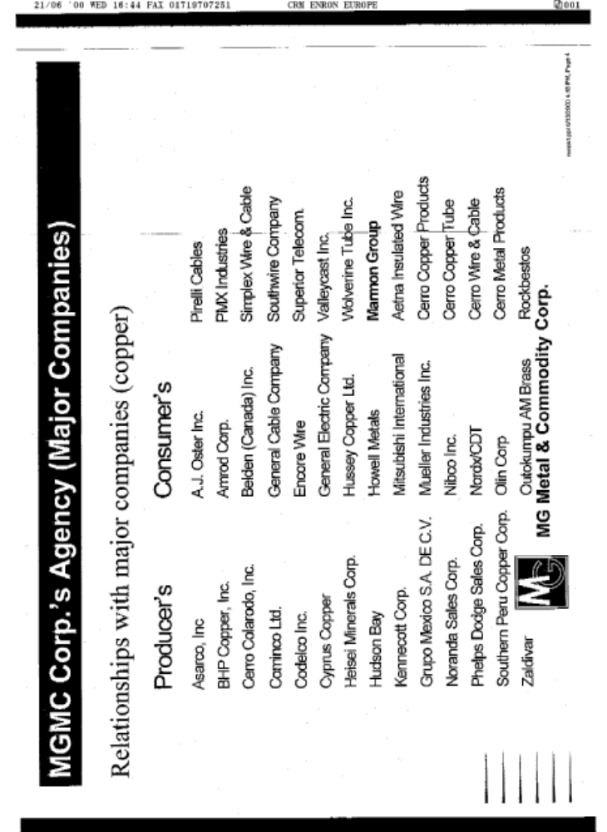

Appendix 2 – Major Zinc customers & suppliers

